**Is the ‘new manager bounce’ a myth?**

**What is the ‘new manager bounce’?**

A ‘new manager bounce’, often spoken about in the media, is when a new manager joins a football team and the team receives a 'bounce', where results are better than they normally would be.

**What is the threshold of matches considered to be within a “bounce” period?**

For my analysis, I used a threshold of a new manager's first **5 matches** as being within the ‘bounce’ period.

**What data was used?**

|  |  |
| --- | --- |
| *League/season dataset used* | Premier League 2015/16 |
| [*Number of managerial changes*](https://en.wikipedia.org/wiki/2015%E2%80%9316_Premier_League) *(excluding preseason)* | 8 |
| *Teams that had a managerial change* | Sunderland, Liverpool, Swansea (x2),  Aston Villa (x2), Chelsea, and Newcastle |

**What metric is used to compare teams with/without a new manager bounce?**

For this analysis, I compared teams’ **points per game (PPG)** in the 5 matches after a new manager was hired versus their PPG during the rest of their matches. It could be argued that a ‘new manager bounce’ should only be compared against matches before the new manager was hired, but I felt that the ‘new manager bounce’ should be a particularly successful period and should stand out from all performances over the whole season if it’s considered to really be a ‘bounce’.

**What defines a ‘significant’ difference between the bounce/non-bounce periods?**

Comparing the two periods (bounce/non-bounce) PPG, I used an **independent samples t-test**, to test if there was a statistical difference between the two periods, with the following hypotheses:

*Null hypothesis H0:* PPG during bounce period = PPG during non-bounce period.

*Alternative hypothesis H1*: PPG during bounce period > PPG during non-bounce period.

If the **p-value** from this test **is greater than** our significance level **0.05**, then we **accept** *H0* and conclude that there is no difference between bounce and non-bounce periods.

If the p-value is lower than 0.05, then we can conclude that the new manager bounce is a real phenomenon where teams gain more points than they normally would.

**Results:**

I’ve split the results into two sections, the first combines all 6 teams that had at least one managerial change and compares all their combined ‘bounce’ periods against their combined ‘non-bounce’ periods. The second compares the two periods for each individual team.

1. **Combined Bounce vs. Non-Bounce periods:**

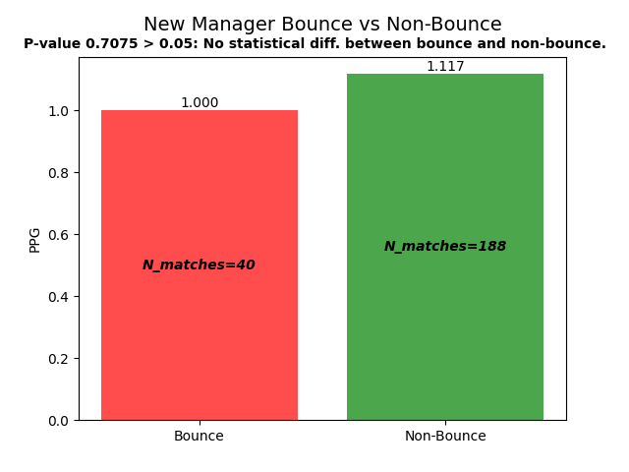

From this analysis, we can conclude that for teams that had at least one managerial change during the Premier League 2015/16 season, there was no statistical difference in PPG between the new manager’s first 5 games and the rest of the teams’ games. Judging by the data used for this analysis, the new manager bounce is purely a myth.

1. **Individual teams Bounce vs. Non-Bounce periods:**

|  |
| --- |
| **Team** |
|   **Manager(s) that left (date left)**  Dick Advocaat (2015-10-04)  **Manager(s) hired (date hired)**  Sam Allardyce (2015-10-09) |

|  |
| --- |
| **Team** |
|   **Manager(s) that left (date left)**  Brendan Rodgers (2015-10-04)    **Manager(s) hired (date hired)**  Jürgen Klopp (2015-10-08) |

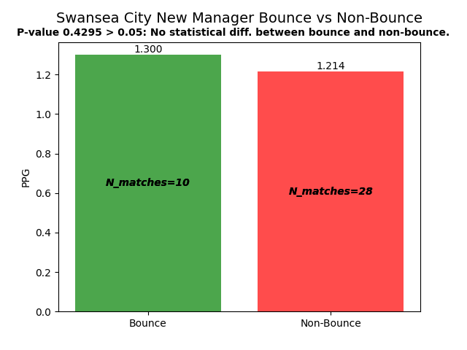

|  |
| --- |
| **Team** |
|   **Manager(s) that left (date left)**  Garry Monk (2015-12-09)  Alan Curtis (2016-01-18)    **Manager(s) hired (date hired)**  Alan Curtis (2015-12-09)  Francesco Guidolin (2016-01-18) |

|  |
| --- |
| **Team** |
| Aston Villa  **Manager(s) that left (date left)**  Tim Sherwood (2015-10-25)  Remi Garde (2016-03-29)    **Manager(s) hired (date hired)**  Remi Garde (2015-11-02)  Eric Black (2016-03-29) |

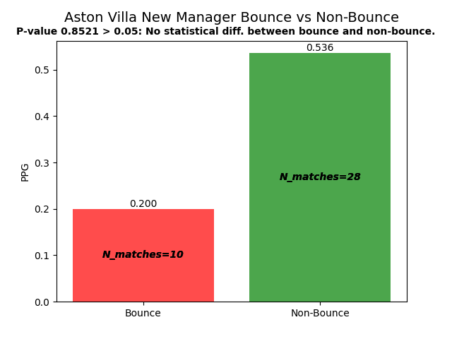

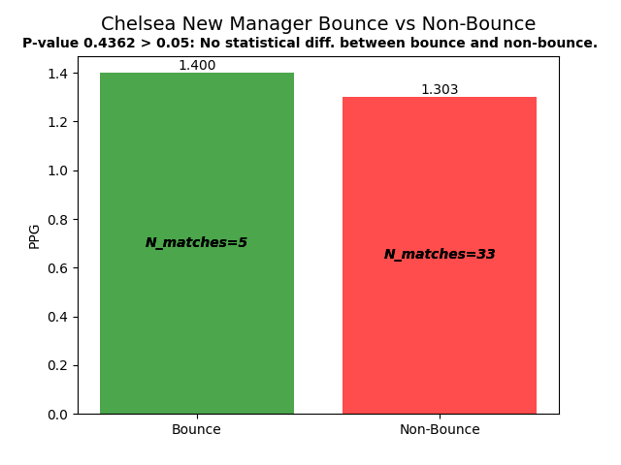

|  |
| --- |
| **Team** |
| Chelsea  **Manager(s) that left (date left)**  José Mourinho (2015-12-17)    **Manager(s) hired (date hired)**  Guus Hiddink (2015-12-20) |

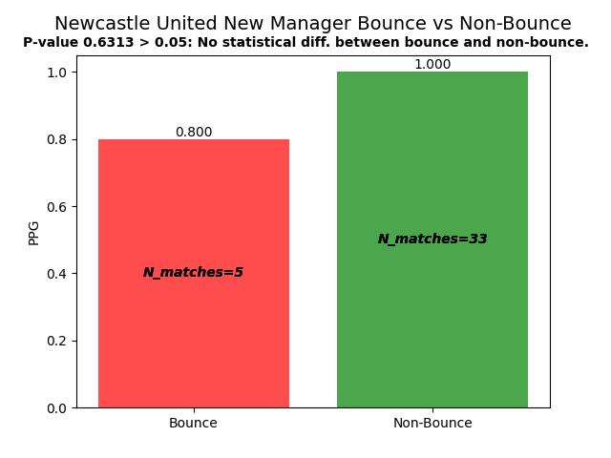

|  |
| --- |
| **Team** |
| Newcastle United  **Manager(s) that left (date left)**  Steve McClaren (2016-03-11)    **Manager(s) hired (date hired)**  Rafael Benitez (2016-03-11) |

Looking at each individual team where a managerial change occurred below, there are no teams where the PPG during the ‘bounce’ period was statistically greater than the PPG during the ‘non-bounce’ period. Four teams had larger average PPG during ‘bounce’ periods (Sunderland, Liverpool, Swansea, and Chelsea), but, looking at their p-values in the graphs from their t-tests, we can see that none of them are below the 0.05 significance level.